Below is JAVA NIO – EXTRA DEEP VERSION
with clear mental models, internals, comparisons, and runnable mini-examples (like we did for java.io, but deeper).

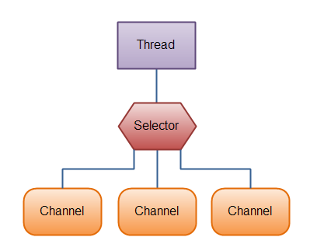

JAVA NIO FUNDAMENTALS (VERY DEEP)

What Exactly Is Java NIO
- NIO = New Input/Output
- Introduced to fix scalability + performance limits of classic I/O
- Packages:
java.nio
java.nio.channels
java.nio.file
Core idea
Java NIO separates where data lives (Buffer) from how data moves (Channel).

The Core Problems with Classic Java I/O
Classic java.io characteristics:
- Stream-based
- Blocking
- One thread per I/O operation
- OS call per read/write
Real problem example
- 5,000 clients
- 5,000 threads
- Context switching overload
- Memory pressure
This is why servers struggled with classic I/O.

What NIO Changes (MENTAL SHIFT)
Old I/O thinking
“Read from stream → JVM waits → process data”
NIO thinking
“Fill buffer → process data when ready → continue”
This shift enables event-driven programming.

Java I/O vs Java NIO (INTERNAL VIEW)
Java I/O (Stream Model)
Thread
↓
InputStream.read() → blocks
↓
OS
- Thread is idle while waiting

Java NIO (Buffer + Channel Model)
Thread
↓
Channel.read(buffer)
↓
Buffer (RAM)
- Thread controls buffer
- Can do other work

Stream vs Channel (INTERVIEW CORE)
Stream
- One-way
- Either read OR write
- Blocking
- Push-based
Channel
- Two-way
- Read AND write
- Can be non-blocking
- Pull-based (buffer controlled)
Interview line
Streams push data, channels let the program pull data into buffers.

Buffer vs Stream (WHY BUFFER EXISTS)
Stream behavior
- Data flows continuously
- No rewind
- No random access
Buffer behavior
- Data is stored temporarily
- You control:
  - where to read
  - where to write
  - how much to process
This control = performance + flexibility

What Is a Buffer (CONCEPT ONLY)
- Fixed-size memory block
- Acts like an array + pointer system
- Used by all NIO operations
You NEVER read directly from a channel
You ALWAYS read into a buffer.

Buffer Core Properties (VERY IMPORTANT)
Every buffer has:
- capacity → total size
- position → current index
- limit → boundary of readable/writable data
- mark → optional bookmark

Buffer Lifecycle (INTERVIEW FAVORITE)
WRITE MODE
put() → position moves

flip()

READ MODE
get() → position moves

clear()
Meaning
- flip() switches write → read
- clear() switches read → write
- Forgetting flip() = most common NIO bug

Very Small Buffer Demo (FOUNDATION EXAMPLE)
import java.nio.ByteBuffer;
public class BufferBasics {
public static void main(String[] args) {
ByteBuffer buffer = ByteBuffer.allocate(5);
buffer.put((byte) 1);
buffer.put((byte) 2);
byte a= 3;
buffer.put(a);
buffer.flip(); // switch to read
while (buffer.hasRemaining()) {
System.out.println(buffer.get());
}
buffer.clear(); // reset for next write
}
}

What this proves:
- Buffer is state-driven
- Program controls read/write

Blocking vs Non-Blocking (CORE DIFFERENCE)
Blocking
- Method waits until operation completes
- Simple logic
- Poor scalability
Non-Blocking
- Method returns immediately
- Thread keeps running
- Check readiness later
Used in
- Servers
- Chat apps
- Event-driven systems

Why Non-Blocking Improves Scalability
- One thread can handle many connections
- Uses OS multiplexing
- No thread-per-client model
Example:
- 1 thread → 1,000 sockets (Selector)

Scatter & Gather (NIO-ONLY CONCEPT)
Scatter Read
- One channel
- Multiple buffers
Use case:
- Protocol parsing (header + body)
Gather Write
- Multiple buffers
- One channel
Use case:
- Construct response efficiently
(Implementation comes in Module 2)

Why NIO Is Faster (INTERNAL REASON)
- Fewer system calls
- Bulk data movement
- Direct buffers (off-heap)
- OS-level optimizations

When You SHOULD Use NIO
- Large file copy
- Server-side socket programming
- High concurrency
- Performance-critical systems

When You SHOULD NOT Use NIO
- Simple file read/write
- Small scripts
- Beginner-level programs
- When readability > performance

Common Beginner Mistakes
- Using NIO everywhere
- Forgetting flip()
- Not understanding buffer state
- Mixing I/O and NIO randomly

Interview Questions
- Why was NIO introduced?
- Stream vs Channel?
- Buffer vs Stream?
- Blocking vs Non-blocking?
- Why NIO scales better than I/O?

ONE-LINE INTERVIEW SUMMARY
Java NIO is a buffer-based, channel-oriented I/O framework that improves scalability and performance by reducing blocking and giving applications direct control over data flow.

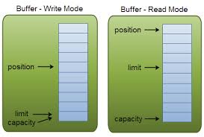
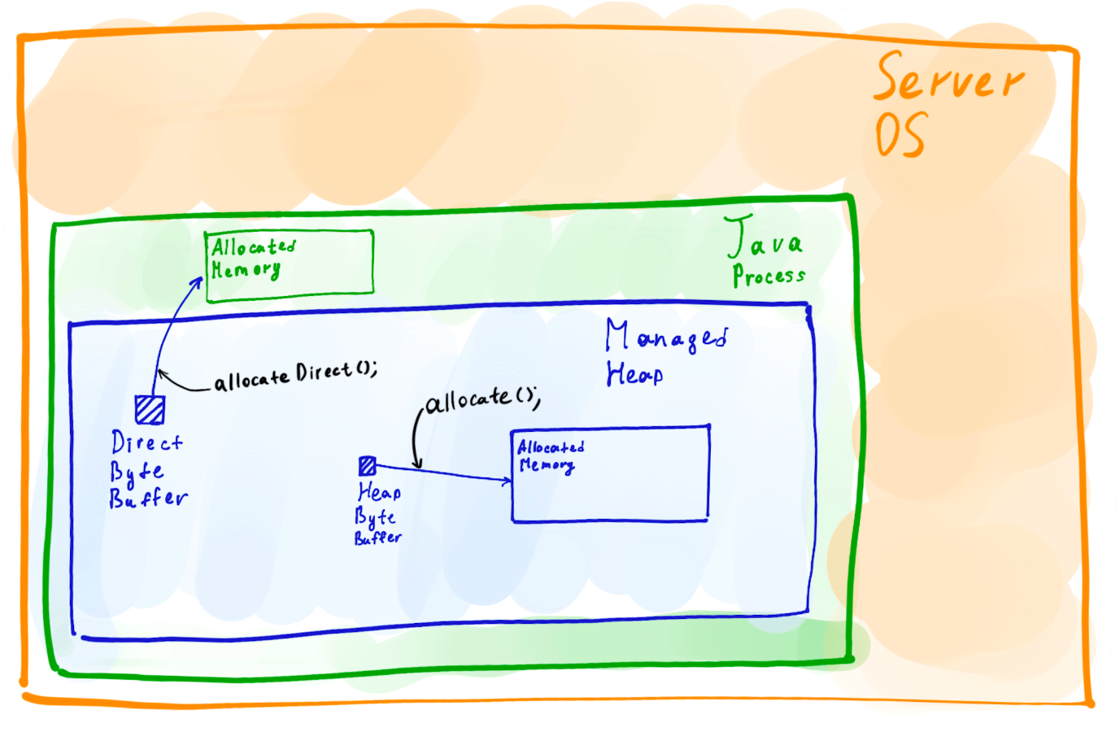

MODULE 1 – BUFFER (JAVA NIO CORE)

What is a Buffer (RECAP + DEEP)
- A Buffer is a fixed-size memory container
- Used to temporarily hold data
- All NIO read/write happens through buffers
Golden rule
In NIO, you never read data directly — you always read into a buffer.

Why Buffers Exist (VERY IMPORTANT)
Classic I/O:
- JVM waits for OS
- Data flows directly
NIO:
- OS fills buffer
- JVM processes buffer
- JVM controls timing
This separation gives:
- Performance
- Control
- Scalability

Buffer Hierarchy
Buffer
├── ByteBuffer
├── CharBuffer
├── IntBuffer
├── LongBuffer
├── FloatBuffer
└── DoubleBuffer

ByteBuffer is the MOST USED (files, network, channels)

Core Buffer Properties (INTERVIEW FAVORITE)
Every buffer has 4 pointers:
- capacity → total size (fixed)
- position → current index
- limit → boundary
- mark → saved position (optional)

Visual Representation
capacity = 10

[ 0 1 2 3 4 5 6 7 8 9 ]
↑
position

Buffer Modes
Buffers operate in two modes:
- Write mode (put data)
- Read mode (get data)
Switching is manual.

Buffer Lifecycle (CRITICAL)
allocate()
↓
put() → WRITE MODE
↓
flip()
↓
get() → READ MODE
↓
clear() / compact()
Forgetting flip() is the #1 NIO bug

ByteBuffer Creation Methods
Heap Buffer
ByteBuffer buffer = ByteBuffer.allocate(10);
- Stored in JVM heap
- Managed by GC
- Slightly slower

Direct Buffer
ByteBuffer buffer = ByteBuffer.allocateDirect(10);
- Stored outside JVM heap
- OS-level memory
- Faster for I/O
- Expensive to create
Interview line
Direct buffers reduce copying between JVM and OS.

ByteBuffer – BASIC EXAMPLE
import java.nio.ByteBuffer;
public class BufferBasicDemo {
public static void main(String[] args) {
ByteBuffer buffer = ByteBuffer.allocate(5);
buffer.put((byte) 10);
buffer.put((byte) 20);
buffer.flip();
while (buffer.hasRemaining()) {
System.out.println(buffer.get());
}
buffer.clear();
}
}

position, limit, capacity (LIVE DEMO)
ByteBuffer buffer = ByteBuffer.allocate(5);
System.out.println(buffer.position()); // 0
System.out.println(buffer.limit()); // 5
buffer.put((byte)1);
buffer.put((byte)2);
System.out.println(buffer.position()); // 2
buffer.flip();
System.out.println(buffer.position()); // 0
System.out.println(buffer.limit()); // 2

flip() – WHAT EXACTLY IT DOES
- limit = current position
- position = 0
Meaning:
“Stop writing, start reading”

clear() vs rewind() vs compact() (VERY IMPORTANT)
clear()
- position = 0
- limit = capacity
- Old data ignored
buffer.clear();
Use when:
- You are DONE reading
- Want to overwrite buffer

rewind()
- position = 0
- limit unchanged
buffer.rewind();
Use when:
- Re-read same data

compact() (ADVANCED & IMPORTANT)
- Keeps unread data
- Moves it to beginning
- Switches to write mode
buffer.compact();
Use case:
- Partial data processing
- Network protocols

compact() – REAL EXAMPLE
ByteBuffer buffer = ByteBuffer.allocate(10);
buffer.put((byte)1);
buffer.put((byte)2);
buffer.put((byte)3);
buffer.flip();
System.out.println(buffer.get()); // read 1
buffer.compact(); // keeps 2,3
buffer.put((byte)4);
buffer.put((byte)5);
buffer.flip();

while (buffer.hasRemaining()) {
System.out.println(buffer.get());
}
Output:
2
3
4
5

mark() and reset()
buffer.mark();
buffer.get();
buffer.reset();
Use case:
- Parsing protocols
- Rollback reading

CharBuffer Example (TEXT DATA)
import java.nio.CharBuffer;
public class CharBufferDemo {
public static void main(String[] args) {
CharBuffer buffer = CharBuffer.allocate(5);
buffer.put('A');
buffer.put('B');
buffer.flip();
while (buffer.hasRemaining()) {
System.out.println(buffer.get());
}
}
}

Wrapping Existing Array
byte[] arr = {1, 2, 3};
ByteBuffer buffer = ByteBuffer.wrap(arr);
Changes in buffer → reflect in array.

Read-Only Buffer
ByteBuffer readOnly = buffer.asReadOnlyBuffer();
Use case:
- Security
- Prevent modification

Buffer Common Mistakes
- Forgetting flip()
- Writing after flip
- Reading without flip
- Assuming buffer auto-expands

Performance Notes
- Heap buffer → general use
- Direct buffer → heavy I/O
- Reuse buffers → avoid GC pressure

Real-Time Buffer Usage
- FileChannel read/write
- SocketChannel communication
- Network protocol parsing
- High-speed file copy

Interview Questions (BUFFER)
- What is buffer?
- position vs limit?
- flip vs clear?
- compact use case?
- Heap vs Direct buffer?

ONE-LINE INTERVIEW SUMMARY
A Buffer is a fixed-size memory container in Java NIO that gives applications full control over reading and writing data, enabling high-performance and scalable I/O.

This module connects Buffers + Real I/O, and is INTERVIEW-CRITICAL.

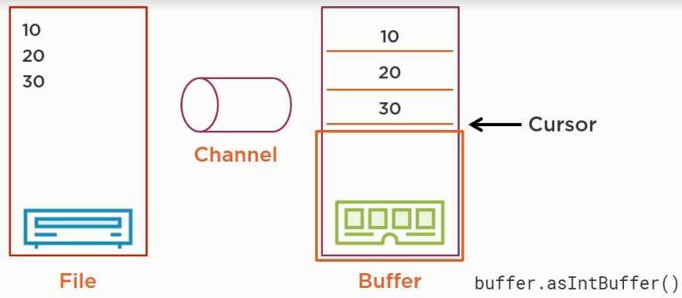
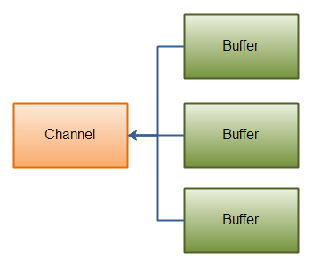

MODULE 2 – CHANNELS (JAVA NIO CORE DATA PIPE)

What is a Channel
- A Channel is a two-way data pipe
- Data flows between Channel and Buffer
- Channels replace streams in NIO
Key rule
Channels NEVER read/write data directly — they always work with Buffers.

Why Channels Exist
Problems with Streams:
- One-direction only
- Blocking
- No random access
- Poor scalability
Channels solve:
- Two-way communication
- Buffer-based I/O
- Optional non-blocking
- High performance

Channel vs Stream (INTERVIEW CORE)
Stream
- One-way
- Blocking
- Sequential
- Push-based
Channel
- Two-way
- Blocking / Non-blocking
- Random access (FileChannel)
- Pull-based
Interview line
Streams push data, Channels exchange data using buffers.

Channel Hierarchy
Channel
├─ FileChannel
├─ SocketChannel
├─ ServerSocketChannel
├─ DatagramChannel

FileChannel is the most important for interviews
FILECHANNEL (MOST USED CHANNEL)

What is FileChannel
- Used for file I/O
- Supports:
  - Read
  - Write
  - Random access
  - Fast file copy
- Works with ByteBuffer

How to Get a FileChannel
Using RandomAccessFile
RandomAccessFile file = new RandomAccessFile("data.txt", "r");
FileChannel channel = file.getChannel();
Modes:
- "r" → read
- "rw" → read/write

Reading File Using FileChannel (BASIC)
import java.io.RandomAccessFile;
import java.nio.ByteBuffer;
import java.nio.channels.FileChannel;

public class FileChannelRead {
public static void main(String[] args) throws Exception {
RandomAccessFile file = new RandomAccessFile("data.txt", "r");
FileChannel channel = file.getChannel();
ByteBuffer buffer = ByteBuffer.allocate(16);
while (channel.read(buffer) > 0) {
buffer.flip();
while (buffer.hasRemaining()) {
System.out.print((char) buffer.get());
}
buffer.clear();
}
channel.close();
file.close();
}
}

Key learning
- read() fills buffer
- flip() switches to read
- clear() prepares for next read

Writing File Using FileChannel
import java.io.RandomAccessFile;
import java.nio.ByteBuffer;
import java.nio.channels.FileChannel;
public class FileChannelWrite {
public static void main(String[] args) throws Exception {
RandomAccessFile file =
new RandomAccessFile("out.txt", "rw");
FileChannel channel = file.getChannel();
ByteBuffer buffer =
ByteBuffer.wrap("Hello NIO Channel".getBytes());
channel.write(buffer);
channel.close();
file.close();
}
}

FileChannel Position (RANDOM ACCESS)
Unlike streams, FileChannel supports random access.
channel.position(5);

Random Write Example
ByteBuffer buffer = ByteBuffer.wrap("JAVA".getBytes());
channel.position(10);
channel.write(buffer);
Used in:
- File editors
- Database engines
- Log patching

File Size
long size = channel.size();

truncate() – Shrink File
channel.truncate(100);
Cuts file to 100 bytes.
HIGH-PERFORMANCE FILE COPY

transferFrom() (INTERVIEW FAVORITE)
import java.nio.channels.FileChannel;
import java.io.RandomAccessFile;
public class FastCopy {
public static void main(String[] args) throws Exception {
FileChannel src = new RandomAccessFile("a.bin", "r").getChannel();
FileChannel dest = new RandomAccessFile("b.bin", "rw").getChannel();
dest.transferFrom(src, 0, src.size());
src.close();
dest.close();
}
}
Why fast:
- OS-level copy
- Minimal JVM involvement
- Zero-copy optimization

transferTo()
src.transferTo(0, src.size(), dest);
Same result, reversed direction.

transferFrom vs Stream Copy
- Stream copy → JVM loop
- FileChannel copy → OS optimized
Interview line
transferFrom() is the fastest file copy mechanism in Java.
SCATTER & GATHER (ADVANCED & INTERVIEW)

Scatter Read
- One channel
- Multiple buffers
ByteBuffer header = ByteBuffer.allocate(10);
ByteBuffer body = ByteBuffer.allocate(20);
ByteBuffer[] buffers = {header, body};
channel.read(buffers);
Used in:
- Network protocols
- Header + payload parsing

Gather Write
- Multiple buffers
- One channel
header.flip();
body.flip();
ByteBuffer[] buffers = {header, body};
channel.write(buffers);

Scatter-Gather Real-World Example
Protocol:
[HEADER][DATA]
- HEADER → metadata
- DATA → content
NIO reads both efficiently without copying.
LOCKING & CONCURRENCY

File Locking
FileLock lock = channel.lock();
- Prevents concurrent write
- Used in:
  - Log files
  - Shared resources

Blocking vs Non-Blocking Channels
- FileChannel → blocking only
- SocketChannel → blocking / non-blocking
(FileChannel doesn’t support selectors)

Common Channel Mistakes
- Forgetting buffer flip
- Not closing channel
- Writing without clearing buffer
- Using FileChannel for small files unnecessarily

Performance Notes
- Use FileChannel for:
  - Large files
  - Random access
  - Fast copy
- Use classic I/O for:
  - Simple tasks

Interview Questions (CHANNELS)
- Channel vs Stream?
- FileChannel vs FileInputStream?
- transferFrom advantage?
- Scatter-gather use case?
- Random access support?

ONE-LINE INTERVIEW SUMMARY
Channels in Java NIO provide two-way, buffer-based data transfer with support for random access and high-performance file operations such as zero-copy transfers.

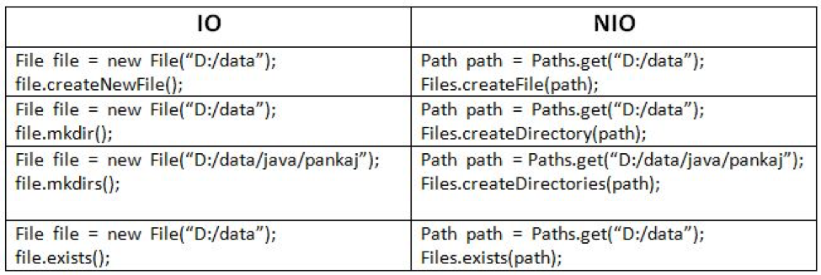

MODULE 3 – PATH & FILES API (java.nio.file)

Why Path & Files Were Introduced (JAVA 7)
Problems with java.io.File:
- Poor error handling (boolean return)
- No symbolic link support
- Weak directory traversal
- Platform quirks
- Not scalable
Solution
- Path → modern path abstraction
- Files → powerful utility operations
Interview line
Path & Files API is a modern replacement for java.io.File.

Path vs File (CORE INTERVIEW COMPARISON)
File:
- Old I/O
- Limited features
- Poor exception details
Path:
- NIO based
- Rich features
- Better error handling
- Works with NIO Channels

What is Path
- Path represents location of a file/directory
- Immutable
- OS-independent
import java.nio.file.Path;
import java.nio.file.Paths;
Path path = Paths.get("data.txt");

Path is NOT a File
- Path ≠ File
- Path does not access disk automatically
- Just a reference

Creating Path (MULTIPLE WAYS)
Path p1 = Paths.get("test.txt");
Path p2 = Paths.get("C:/logs/app.log");
Path p3 = Path.of("data/config.yaml"); // Java 11+

Path Important Methods
path.getFileName();
path.getParent();
path.getRoot();
path.toAbsolutePath();
path.normalize();

Absolute vs Relative Path
Path p = Paths.get("a/b/c.txt");

System.out.println(p.isAbsolute());
System.out.println(p.toAbsolutePath());

Resolving Paths (REAL-TIME USE)
Path base = Paths.get("/home/user");
Path child = base.resolve("docs/file.txt");
Used in:
- Config loading
- Dynamic file creation

Relativize Paths
Path p1 = Paths.get("/home/user");
Path p2 = Paths.get("/home/user/docs");

System.out.println(p1.relativize(p2)); // docs
FILES UTILITY CLASS (MOST POWERFUL)

What is Files Class
- Static utility class
- Performs actual file operations
- Works with Path

Files.exists / notExists
Files.exists(path);
Files.notExists(path);
Better than File.exists()

Creating Files & Directories
Files.createFile(Path.of("a.txt"));
Files.createDirectory(Path.of("logs"));
Files.createDirectories(Path.of("a/b/c"));

Reading Small Files (EASY & COMMON)
Read All Lines
List<String> lines = Files.readAllLines(Path.of("data.txt"));
Loads entire file into memory
Use only for small files

Reading Large Files (STREAMING)
try (Stream<String> stream = Files.lines(Path.of("data.txt"))) {
stream.forEach(System.out::println);
}
- Lazy loading
- Memory efficient

Writing Files
Files.write( Path.of("out.txt"),"Hello NIO".getBytes());

Append Mode
Files.write(
Path.of("out.txt"),
"More data".getBytes(),
StandardOpenOption.APPEND
);

Copy File (INTERVIEW FAVORITE)
Files.copy(
Path.of("a.txt"),
Path.of("b.txt"),
StandardCopyOption.REPLACE_EXISTING
);

Move / Rename File
Files.move(
Path.of("old.txt"),
Path.of("new.txt"),
StandardCopyOption.REPLACE_EXISTING
);

Delete File
Files.delete(Path.of("temp.txt"));
Throws exception if file missing (safe)

File Attributes (METADATA)
Files.size(path);
Files.isReadable(path);
Files.isWritable(path);
Files.getLastModifiedTime(path);

Directory Traversal (VERY IMPORTANT)
List Directory
try (Stream<Path> paths = Files.list(Path.of("logs"))) {
paths.forEach(System.out::println);
}

Recursive Walk (POWERFUL)
try (Stream<Path> paths = Files.walk(Path.of("project"))) {
paths.filter(Files::isRegularFile)
.forEach(System.out::println);
}
Used in:
- File search
- Cleanup tools
- Build systems

Filter by Extension
Files.walk(Path.of("."))
.filter(p -> p.toString().endsWith(".java"))
.forEach(System.out::println);
WATCHSERVICE (FILE CHANGE DETECTION)

What is WatchService
- Monitors directory changes
- OS-level notifications
- Event-driven
Used in:
- IDEs
- Auto-reload servers
- Log monitors

WatchService Example (ADVANCED & REAL-TIME)
import java.nio.file.*;
public class DirectoryWatcher {
public static void main(String[] args) throws Exception {
WatchService watchService = FileSystems.getDefault().newWatchService();
Path dir = Paths.get("logs");
dir.register(
watchService,
StandardWatchEventKinds.ENTRY_CREATE,
StandardWatchEventKinds.ENTRY_DELETE,
StandardWatchEventKinds.ENTRY_MODIFY
);
while (true) {
WatchKey key = watchService.take();
for (WatchEvent<?> event : key.pollEvents()) {
System.out.println(event.kind() + " : " + event.context());
}
key.reset();
}
}
}

Real-Time Use Cases
- Auto-reload configuration
- Log file monitoring
- File synchronization tools
- Backup systems

Path + Files vs File (FINAL INTERVIEW TABLE)
Feature | File | Path + Files
API | Old | Modern
Error handling | Weak | Strong
Traversal | Limited | Powerful
Watch support | No | Yes
Symbolic links | No | Yes

Common Mistakes
- Using Files.readAllLines for huge files
- Forgetting try-with-resources
- Assuming Files APIs are always faster
- Ignoring exceptions

Interview Questions (PATH & FILES)
- Path vs File?
- Files.readAllLines vs Files.lines?
- walk vs list?
- WatchService use case?
- How to monitor file changes?

ONE-LINE INTERVIEW SUMMARY
Path and Files APIs provide a modern, powerful, and safer way to handle file system operations in Java, replacing legacy File-based I/O with scalable NIO features.


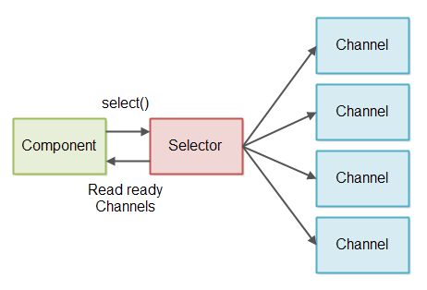
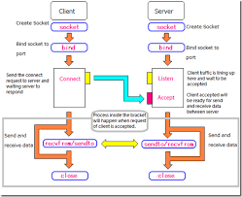

MODULE 4 – NON-BLOCKING I/O (Selectors, SocketChannel, ServerSocketChannel)

What is Non-Blocking I/O (NIO Core Idea)
- Non-blocking I/O means:
  - I/O calls do not wait
  - Method returns immediately
  - Thread continues execution
Meaning
A single thread can manage many connections without waiting on any one of them.

Why Non-Blocking I/O Is Needed
Blocking I/O Problem
- 1 client → 1 thread
- 10,000 clients → 10,000 threads
- High memory + context switching
Non-Blocking I/O Solution
- Few threads
- Thousands of connections
- Event-driven model
Interview line
Non-blocking I/O improves scalability by decoupling threads from I/O waiting.

Blocking vs Non-Blocking (CLEAR DIFFERENCE)
Blocking
- Thread waits until data is available
- Simple programming model
- Poor scalability
Non-Blocking
- Thread checks readiness
- Continues if not ready
- Excellent scalability

Core Components of Non-Blocking NIO
Three pillars:
- Channel → data source
- Buffer → data container
- Selector → event manager

What is a Selector (MOST IMPORTANT CLASS)
- Selector monitors multiple channels
- Tells:
  - Which channel is ready to read
  - Which is ready to write
  - Which has incoming connection
Meaning
Selector allows one thread to manage many channels.

Selector Architecture (MENTAL MODEL)
Thread
↓
Selector
↓
Multiple Channels
↓
OS (select / poll / epoll)
Selector uses OS multiplexing internally.

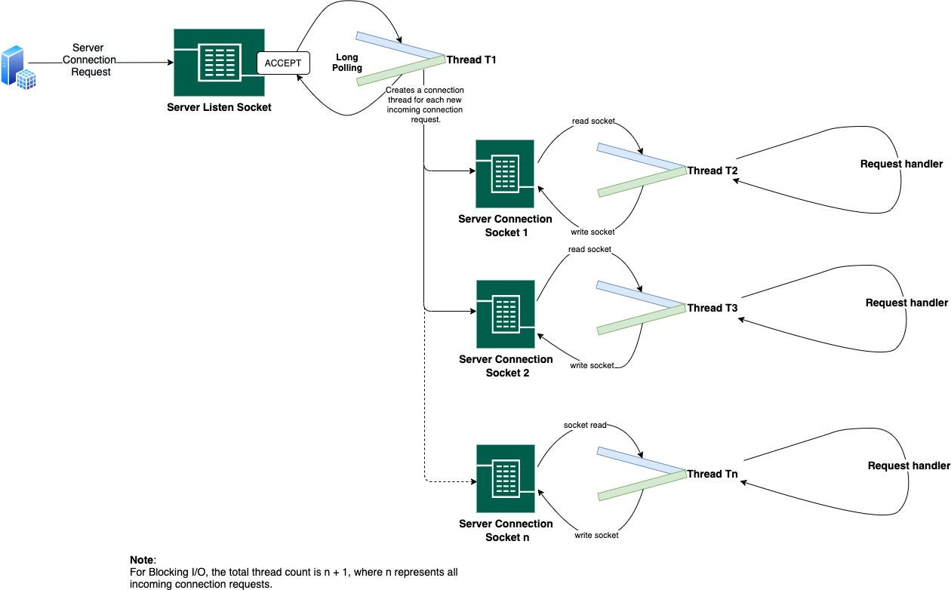


JAVA NIO – SOCKET CHANNEL (ULTRA DEEP GUIDE)

1. Problem Statement (WHY SOCKET PROGRAMMING EXISTS)
We want:
- Client sends data
- Server receives data
- Server responds
- Client reads response
This is network I/O, not file I/O.

2. BEFORE NIO – HOW WE DID SOCKET PROGRAMMING (java.io)
Classic Blocking Model
- ServerSocket
- Socket
- InputStream / OutputStream
- One client = one thread

Blocking Server (java.io)
// BlockingServer.java
import java.net.*;
import java.io.*;

public class BlockingServer {
public static void main(String[] args) throws Exception {

ServerSocket serverSocket = new ServerSocket(5000);
System.out.println("Server started...");

while (true) {
Socket socket = serverSocket.accept(); // BLOCKS
new Thread(() -> handleClient(socket)).start();
}
}

static void handleClient(Socket socket) {
try {
BufferedReader in =
new BufferedReader(
new InputStreamReader(socket.getInputStream()));
PrintWriter out =
new PrintWriter(socket.getOutputStream(), true);

String msg = in.readLine(); // BLOCKS
out.println("Echo: " + msg);

socket.close();
} catch (Exception e) {
e.printStackTrace();
}
}
}

Blocking Client (java.io)
// BlockingClient.java
import java.net.*;
import java.io.*;

public class BlockingClient {
public static void main(String[] args) throws Exception {

Socket socket = new Socket("localhost", 5000);

PrintWriter out =
new PrintWriter(socket.getOutputStream(), true);
BufferedReader in =
new BufferedReader(
new InputStreamReader(socket.getInputStream()));

out.println("Hello Server");
System.out.println(in.readLine());

socket.close();
}
}

Problems with Blocking IO
- Each client needs one thread
- Threads are expensive
- 10,000 clients → 10,000 threads ❌
- Context switching overhead
- Poor scalability
This is where NIO comes in

3. AFTER NIO – SOCKET PROGRAMMING WITH SocketChannel

4. Core NIO Socket Classes
- ServerSocketChannel → server side
- SocketChannel → client connection
- Selector → manage many clients
- ByteBuffer → data container

5. Blocking vs Non-Blocking (MENTAL MODEL)
Blocking
Thread waits → client sends data → thread wakes
Non-Blocking
Thread checks readiness → continues → handles when ready

PART 1 – SIMPLE NIO SOCKET (ONE CLIENT)

6. NIO Server – Single Client (Blocking Mode)
First we use NIO without selector (easy transition)
// NioServerSingleClient.java
import java.net.InetSocketAddress;
import java.nio.ByteBuffer;
import java.nio.channels.ServerSocketChannel;
import java.nio.channels.SocketChannel;

public class NioServerSingleClient {
public static void main(String[] args) throws Exception {

ServerSocketChannel server =
ServerSocketChannel.open();
server.bind(new InetSocketAddress(6000));

System.out.println("NIO Server waiting...");

SocketChannel client = server.accept(); // BLOCKING
ByteBuffer buffer = ByteBuffer.allocate(1024);

client.read(buffer);
buffer.flip();

System.out.println("Received: "
+ new String(buffer.array(), 0, buffer.limit()));

buffer.clear();
buffer.put("Hello Client".getBytes());
buffer.flip();
client.write(buffer);

client.close();
server.close();
}
}

7. NIO Client – Single Client
// NioClientSingle.java
import java.net.InetSocketAddress;
import java.nio.ByteBuffer;
import java.nio.channels.SocketChannel;

public class NioClientSingle {
public static void main(String[] args) throws Exception {

SocketChannel client =
SocketChannel.open(
new InetSocketAddress("localhost", 6000));

ByteBuffer buffer = ByteBuffer.allocate(1024);

buffer.put("Hello Server".getBytes());
buffer.flip();
client.write(buffer);

buffer.clear();
client.read(buffer);
buffer.flip();

System.out.println("Server says: "
+ new String(buffer.array(), 0, buffer.limit()));

client.close();
}
}

8. What We Achieved So Far
- Used SocketChannel
- Used ByteBuffer
- Still blocking
- Still one client only
This matches classic IO, but cleaner buffer control.

PART 2 – NON-BLOCKING NIO (MULTI-CLIENT SERVER)

9. Why Selector is Needed
Goal:
- One thread
- Multiple clients
- No blocking
Selector:
- Watches multiple channels
- Tells which channel is ready

10. NIO Multi-Client Server (Non-Blocking)
// NioMultiClientServer.java
import java.net.InetSocketAddress;
import java.nio.ByteBuffer;
import java.nio.channels.*;
import java.util.Iterator;

public class NioMultiClientServer {
public static void main(String[] args) throws Exception {

ServerSocketChannel server =
ServerSocketChannel.open();
server.bind(new InetSocketAddress(7000));
server.configureBlocking(false);

Selector selector = Selector.open();
server.register(selector, SelectionKey.OP_ACCEPT);

System.out.println("NIO Multi-client server started");

while (true) {
selector.select();

Iterator<SelectionKey> keys =
selector.selectedKeys().iterator();

while (keys.hasNext()) {
SelectionKey key = keys.next();
keys.remove();

if (key.isAcceptable()) {
SocketChannel client =
server.accept();
client.configureBlocking(false);
client.register(selector, SelectionKey.OP_READ);
}

if (key.isReadable()) {
SocketChannel client =
(SocketChannel) key.channel();

ByteBuffer buffer =
ByteBuffer.allocate(1024);

int read = client.read(buffer);
if (read == -1) {
client.close();
continue;
}

buffer.flip();
client.write(buffer); // echo back
}
}
}
}
}

11. NIO Client (Same Client, Multiple Instances)
// NioClient.java
import java.net.InetSocketAddress;
import java.nio.ByteBuffer;
import java.nio.channels.SocketChannel;

public class NioClient {
public static void main(String[] args) throws Exception {

SocketChannel client =
SocketChannel.open(
new InetSocketAddress("localhost", 7000));

ByteBuffer buffer =
ByteBuffer.wrap("Hello from client".getBytes());

client.write(buffer);
client.close();
}
}
Run this client multiple times → same server handles all.

12. STEP-BY-STEP DATA FLOW (MULTI-CLIENT)
- Server registers with selector
- Client connects → OP_ACCEPT
- Client sends data → OP_READ
- Server reads buffer
- Server responds
- No thread blocking
- One thread handles many clients

13. CLASSIC IO vs NIO – STEP-BY-STEP COMPARISON
Step | Classic IO | NIO
Accept | server.accept() blocks | selector signals
Read | readLine() blocks | read if ready
Threads | 1 per client | 1 for many
Scalability | Poor | Excellent
Control | Stream | Buffer
Performance | Medium | High

14. WHEN TO USE WHAT (INTERVIEW GOLD)
Use Classic IO
- Simple apps
- Few clients
- Readability preferred
Use NIO
- High concurrency
- Chat servers
- Game servers
- APIs, gateways

15. COMMON INTERVIEW QUESTIONS
- Why SocketChannel over Socket?
- How selector handles multiple clients?
- Blocking vs non-blocking?
- Why FileChannel cannot be non-blocking?
- How data flows in NIO socket?

FINAL ONE-LINE SUMMARY
Java NIO SocketChannel enables scalable, non-blocking client-server communication by using buffers and selectors, allowing a single thread to efficiently manage multiple client connections.

Channel Types Used with Selector
Only SelectableChannel works:
- SocketChannel
- ServerSocketChannel
- DatagramChannel
FileChannel does NOT support non-blocking mode

ServerSocketChannel (SERVER SIDE)
Purpose
- Accept incoming client connections
- Non-blocking mode supported

Basic ServerSocketChannel Setup
import java.nio.channels.ServerSocketChannel;
import java.net.InetSocketAddress;

ServerSocketChannel server =
ServerSocketChannel.open();

server.bind(new InetSocketAddress(8080));
server.configureBlocking(false);

SocketChannel (CLIENT CONNECTION)
- Represents a TCP connection
- Can be blocking or non-blocking

Client SocketChannel Example
import java.nio.channels.SocketChannel;
import java.net.InetSocketAddress;

SocketChannel client =
SocketChannel.open();

client.connect(new InetSocketAddress("localhost", 8080));

Registering Channel with Selector
import java.nio.channels.Selector;

Selector selector = Selector.open();

server.register(selector, SelectionKey.OP_ACCEPT);

SelectionKey (EVENT INFORMATION)
Each registered channel produces a SelectionKey.
Important operations:
- OP_ACCEPT
- OP_READ
- OP_WRITE
- OP_CONNECT

Selector Event Loop (CORE PATTERN)
while (true) {
selector.select(); // blocks until event

Set<SelectionKey> keys = selector.selectedKeys();

for (SelectionKey key : keys) {
if (key.isAcceptable()) {
// new connection
}
if (key.isReadable()) {
// read data
}
if (key.isWritable()) {
// write data
}
}
keys.clear();
}
This loop is the heart of NIO servers.

COMPLETE NON-BLOCKING SERVER EXAMPLE

Non-Blocking Echo Server (STEP-BY-STEP)
Server Code
import java.net.InetSocketAddress;
import java.nio.ByteBuffer;
import java.nio.channels.*;
import java.util.Iterator;

public class NioEchoServer {
public static void main(String[] args) throws Exception {

ServerSocketChannel server = ServerSocketChannel.open();
server.bind(new InetSocketAddress(9090));
server.configureBlocking(false);

Selector selector = Selector.open();
server.register(selector, SelectionKey.OP_ACCEPT);

ByteBuffer buffer = ByteBuffer.allocate(1024);

while (true) {
selector.select();

Iterator<SelectionKey> it =
selector.selectedKeys().iterator();

while (it.hasNext()) {
SelectionKey key = it.next();
it.remove();

if (key.isAcceptable()) {
SocketChannel client =
server.accept();
client.configureBlocking(false);
client.register(selector, SelectionKey.OP_READ);
}

if (key.isReadable()) {
SocketChannel client =
(SocketChannel) key.channel();

buffer.clear();
int read = client.read(buffer);

if (read == -1) {
client.close();
continue;
}

buffer.flip();
client.write(buffer);
}
}
}
}
}

What Happens Internally (SERVER FLOW)
- Selector waits for events
- New client arrives → OP_ACCEPT
- Client sends data → OP_READ
- Server echoes data back
- Single thread handles many clients

Why This Scales So Well
- No thread per client
- No blocking reads
- OS handles readiness checks
- Minimal memory usage

OP_ACCEPT / OP_READ / OP_WRITE Meaning
- OP_ACCEPT → new client connection
- OP_READ → data available
- OP_WRITE → ready to write data

Common Non-Blocking Pitfalls
- Forgetting configureBlocking(false)
- Not clearing selected keys
- Blocking inside selector loop
- Using FileChannel with selector

Performance Characteristics
- Handles thousands of connections
- Low memory footprint
- Ideal for:
  - Chat servers
  - Game servers
  - Proxy servers

When to Use Non-Blocking NIO
- High concurrency servers
- Long-lived connections
- Network-intensive systems

When NOT to Use It
- Simple client-server apps
- Low traffic systems
- When complexity outweighs benefit

Interview Questions (NON-BLOCKING NIO)
- Why selector needed?
- How one thread handles many clients?
- Blocking vs non-blocking?
- FileChannel limitation?
- Selector internal working?

ONE-LINE INTERVIEW SUMMARY
Java NIO non-blocking I/O uses selectors and channels to allow a single thread to efficiently manage thousands of concurrent connections without blocking.



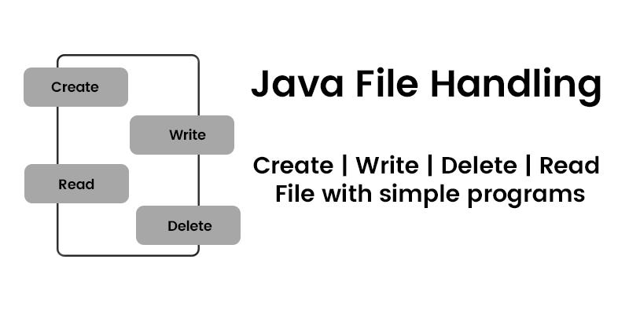

MODULE 5 – ASYNCHRONOUS I/O (java.nio.channels, NIO.2)

1. What is Asynchronous I/O
- Introduced in Java 7 (NIO.2)
- I/O operation executes in background
- JVM notifies you when operation completes
Meaning
Asynchronous I/O lets you start an I/O operation and continue working without waiting for its completion.

Async I/O vs Non-Blocking I/O (IMPORTANT DIFFERENCE)
Non-Blocking (Selector based)
- You poll for readiness
- Thread still manages I/O
- Event-driven
Asynchronous (NIO.2)
- You submit request
- OS/JVM performs I/O
- Callback or Future notifies completion
Interview line
Non-blocking avoids waiting, asynchronous avoids even managing the wait.

When Asynchronous I/O is Used
- Large file read/write
- Background processing
- Cloud storage
- File servers
- Reactive systems

Core Async I/O Classes
- AsynchronousFileChannel
- CompletionHandler
- Future<V>

What is AsynchronousFileChannel
- Reads/writes files asynchronously
- Does not block calling thread
- Uses OS or thread pool internally
AsynchronousFileChannel channel =
AsynchronousFileChannel.open(Path.of("data.txt"));

Two Ways to Use Async I/O
- Future-based
- Callback-based (CompletionHandler)
APPROACH 1 – FUTURE-BASED ASYNC I/O

Future-Based Async Read (BASIC)
import java.nio.ByteBuffer;
import java.nio.channels.AsynchronousFileChannel;
import java.nio.file.Path;
import java.util.concurrent.Future;

public class AsyncReadFuture {
public static void main(String[] args) throws Exception {

AsynchronousFileChannel channel =
AsynchronousFileChannel.open(Path.of("data.txt"));

ByteBuffer buffer = ByteBuffer.allocate(1024);

Future<Integer> result =
channel.read(buffer, 0);

// main thread can do other work here

int bytesRead = result.get(); // waits only here

buffer.flip();
while (buffer.hasRemaining()) {
System.out.print((char) buffer.get());
}

channel.close();
}
}

How This Works Internally
- read() submits request
- JVM/OS performs I/O
- Future completes
- get() retrieves result

Drawback of Future-Based Approach
- get() blocks
- No event notification
- Less flexible
Used when:
- Simple async logic
- Limited concurrency
APPROACH 2 – CALLBACK-BASED ASYNC I/O (BEST PRACTICE)

CompletionHandler (CORE CONCEPT)
CompletionHandler<Integer, Attachment>
- completed() → success
- failed() → failure
- Attachment → user-defined context

Async Read Using CompletionHandler (DEEP)
import java.nio.ByteBuffer;
import java.nio.channels.AsynchronousFileChannel;
import java.nio.channels.CompletionHandler;
import java.nio.file.Path;

public class AsyncReadCallback {
public static void main(String[] args) throws Exception {

AsynchronousFileChannel channel =
AsynchronousFileChannel.open(Path.of("data.txt"));

ByteBuffer buffer = ByteBuffer.allocate(1024);

channel.read(
buffer,
0,
buffer,
new CompletionHandler<Integer, ByteBuffer>() {

@Override
public void completed(Integer result, ByteBuffer buf) {
buf.flip();
while (buf.hasRemaining()) {
System.out.print((char) buf.get());
}
}

@Override
public void failed(Throwable exc, ByteBuffer buf) {
System.out.println("Read failed");
}
}
);

Thread.sleep(2000); // keep JVM alive
channel.close();
}
}

Why CompletionHandler is Powerful
- No blocking
- Event-driven
- Scales well
- True async behavior
Interview line
CompletionHandler enables fully asynchronous, callback-driven file I/O.
ASYNC WRITE EXAMPLES

Async Write Using CompletionHandler
import java.nio.ByteBuffer;
import java.nio.channels.AsynchronousFileChannel;
import java.nio.channels.CompletionHandler;
import java.nio.file.Path;
import java.nio.file.StandardOpenOption;

public class AsyncWriteCallback {
public static void main(String[] args) throws Exception {

AsynchronousFileChannel channel =
AsynchronousFileChannel.open(
Path.of("out.txt"),
StandardOpenOption.WRITE,
StandardOpenOption.CREATE
);

ByteBuffer buffer =
ByteBuffer.wrap("Hello Async NIO".getBytes());

channel.write(
buffer,
0,
null,
new CompletionHandler<Integer, Void>() {

@Override
public void completed(Integer result, Void att) {
System.out.println("Write completed");
}

@Override
public void failed(Throwable exc, Void att) {
System.out.println("Write failed");
}
}
);

Thread.sleep(1000);
channel.close();
}
}

Thread Model of Async I/O
- Uses system async I/O (if supported)
- Otherwise uses internal thread pool
- No user thread blocked

Async vs Selector-Based NIO
Feature | Selector NIO | Async NIO
Waiting | Polling | Callback
Threads | Few | Managed
Complexity | High | Medium
Best for | Sockets | Files

Real-Time Use Cases
- Large file uploads
- Background report generation
- Cloud file processing
- Media streaming backends

Common Mistakes
- Closing channel too early
- JVM exiting before callback
- Blocking inside callback
- Using async for tiny files

When to Use Async I/O
- Large files
- Background tasks
- Reactive systems
- Performance-critical file operations

When NOT to Use Async I/O
- Simple file read/write
- Small scripts
- Tight synchronous logic

Interview Questions (ASYNC NIO)
- Async vs non-blocking?
- CompletionHandler vs Future?
- How callbacks executed?
- Is FileChannel async?
- JVM exit problem?

ONE-LINE INTERVIEW SUMMARY
Asynchronous I/O in Java NIO.2 enables true non-blocking file operations using callbacks or futures, allowing background execution without tying up application threads.

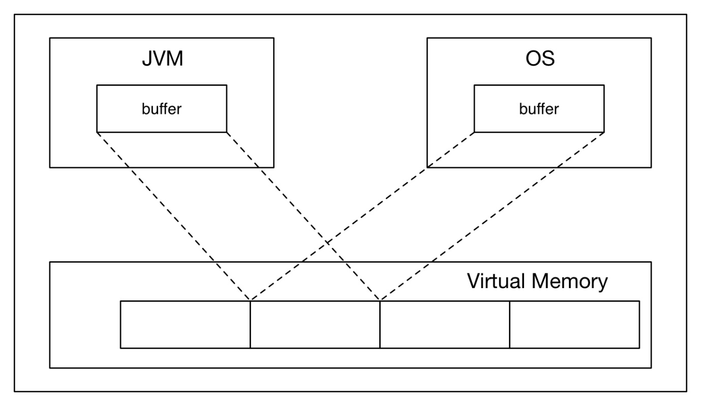
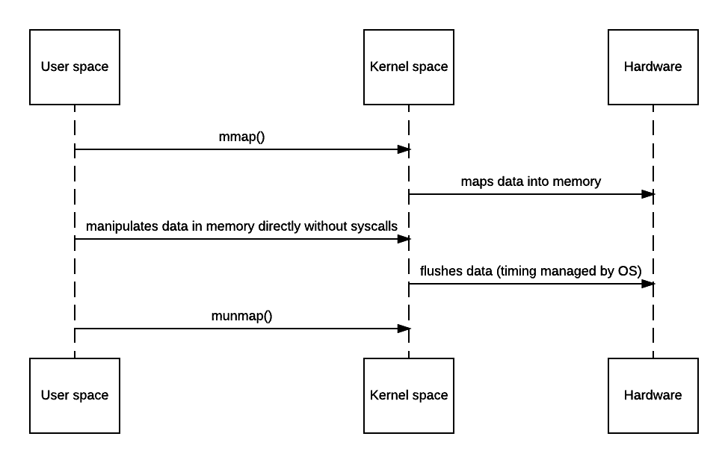

MODULE 6 – MEMORY-MAPPED FILES (java.nio)

What is a Memory-Mapped File
- A memory-mapped file maps file content directly into memory
- File data is accessed as if it were a memory array
- Implemented via MappedByteBuffer
Meaning
Memory-mapped files allow Java programs to treat file contents like in-memory data using OS virtual memory.

Why Memory-Mapped Files Exist
Problems with traditional I/O:
- Repeated read/write system calls
- Data copied between:
  - Disk → Kernel → JVM
- Slower for very large files
Memory-mapped files solve:
- Zero-copy (or near zero-copy)
- OS handles paging
- Extremely fast random access

Where Memory-Mapped Files Fit
Program ↔ Virtual Memory ↔ OS Page Cache ↔ Disk
No explicit read()/write() calls after mapping.

Key Class – MappedByteBuffer
- Subclass of ByteBuffer
- Represents mapped region of file
- Lives outside JVM heap
- Managed by OS virtual memory

How Memory Mapping Works (INTERNAL VIEW)
- File region mapped to virtual memory
- OS loads pages on demand
- Page faults handled by OS
- JVM accesses memory directly
Interview line
Memory-mapped files leverage OS virtual memory for file I/O.

How to Create a Memory-Mapped File
You need:
- RandomAccessFile
- FileChannel
- map() method

FileChannel.map() Method
MappedByteBuffer map(
FileChannel.MapMode mode,
long position,
long size
)
Modes:
- READ_ONLY
- READ_WRITE
- PRIVATE (copy-on-write)
BASIC MEMORY-MAPPED READ EXAMPLE

Read File Using MappedByteBuffer
import java.io.RandomAccessFile;
import java.nio.MappedByteBuffer;
import java.nio.channels.FileChannel;

public class MappedReadDemo {
public static void main(String[] args) throws Exception {

RandomAccessFile file =
new RandomAccessFile("data.txt", "r");

FileChannel channel = file.getChannel();

MappedByteBuffer buffer =
channel.map(
FileChannel.MapMode.READ_ONLY,
0,
channel.size()
);

while (buffer.hasRemaining()) {
System.out.print((char) buffer.get());
}

channel.close();
file.close();
}
}

What Happens Here
- No explicit read() call
- OS loads file pages lazily
- Access via buffer.get()
MEMORY-MAPPED WRITE EXAMPLE

Write Using Memory-Mapped File
import java.io.RandomAccessFile;
import java.nio.MappedByteBuffer;
import java.nio.channels.FileChannel;

public class MappedWriteDemo {
public static void main(String[] args) throws Exception {

RandomAccessFile file =
new RandomAccessFile("out.txt", "rw");

FileChannel channel = file.getChannel();

MappedByteBuffer buffer =
channel.map(
FileChannel.MapMode.READ_WRITE,
0,
1024
);

buffer.put("Hello Memory Mapped File".getBytes());

channel.close();
file.close();
}
}

flush() vs force()
For memory-mapped files:
buffer.force();
- Forces changes to disk
- Similar to flush()
- OS decides actual timing

Random Access (SUPER FAST)
buffer.position(100);
buffer.put((byte) 'A');
Used in:
- Databases
- Index files
- Log patching

Memory-Mapped vs FileChannel Read
Feature | FileChannel | MappedByteBuffer
System calls | Yes | Minimal
Copy overhead | Yes | No
Random access | Yes | Extremely fast
Large files | Good | Excellent
Complexity | Medium | High

Performance Advantage (WHY IT’S FAST)
- OS page cache
- No JVM buffering
- No user-space copy
- Lazy loading
- Hardware-level optimizations

Real-Time Use Cases
- Database engines
- Search indexes
- Big log processing
- Media file handling
- Trading systems

Limitations & Risks (INTERVIEW CRITICAL)
- File remains mapped until GC
- Cannot explicitly unmap (Java ≤ 8)
- Large mappings consume virtual memory
- Platform-dependent behavior
Interview trap
Memory-mapped files are fast but dangerous if misused.

Unmapping Problem (IMPORTANT)
- No public API to unmap
- Happens when:
  - Buffer GCed
  - JVM exits
Java 9+ improves cleanup internally.

When to Use Memory-Mapped Files
- Huge files (GBs)
- Random access heavy
- Performance-critical systems

When NOT to Use Them
- Small files
- Simple read/write
- Short-lived programs
- Limited virtual memory

Common Mistakes
- Mapping entire huge file unnecessarily
- Forgetting force() when needed
- Using mapped files for small files
- Expecting immediate disk write

Interview Questions (MEMORY-MAPPED FILES)
- What is memory-mapped file?
- Why faster than stream I/O?
- MappedByteBuffer vs ByteBuffer?
- Unmapping problem?
- When to avoid memory mapping?

ONE-LINE INTERVIEW SUMMARY
Memory-mapped files use OS virtual memory to map file contents directly into memory, enabling extremely fast, zero-copy file access for large and performance-critical applications.

